# Big Data Hadoop Training

Session 8 Assignment 2 Solution:

Task

**Create a sample dataset and implement the below Pig commands on the same dataset.**

**Sample dataset (used) –**

/My_Downloads/Assignments_BDH/BDDS8A2/student_details.txt

/My_Downloads/Assignments_BDH/BDDS8A2/student_details.txt

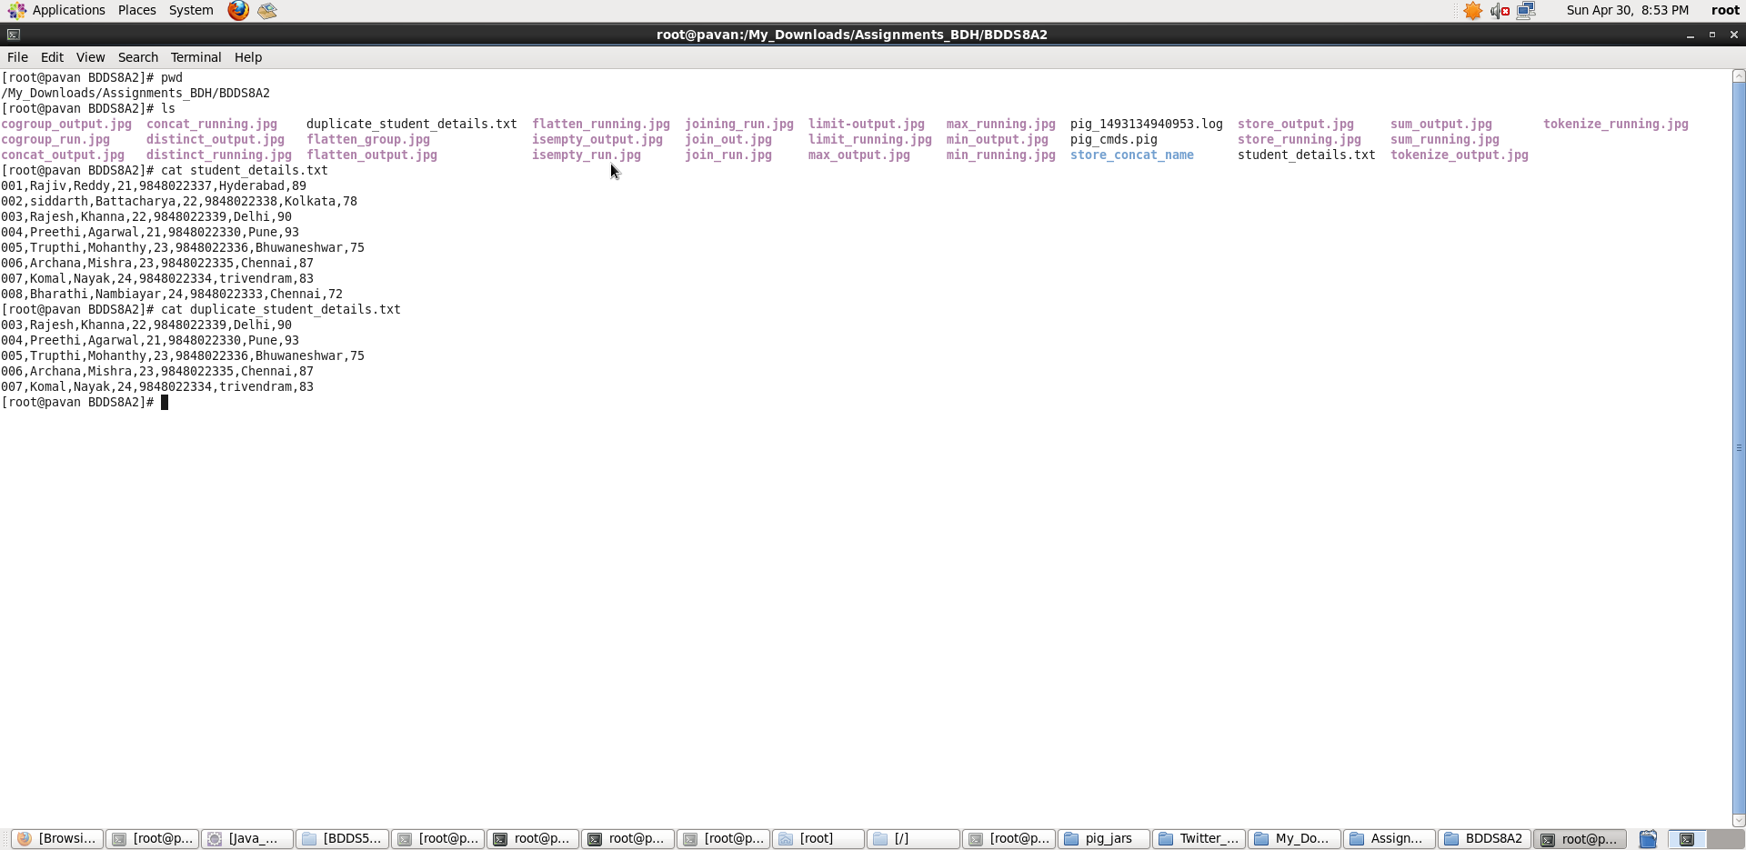

**Pig Commands:**

1. Concat

**Pig Latin Script**:

student_details = LOAD './student_details.txt' USING PigStorage(',') as (Id:int, firstName:chararray, lastName:chararray, age:int, phone_no:chararray, gpa:int);

concat_output = FOREACH student_details GENERATE CONCAT (firstName,'*',lastName);

dump concat_output;

**Explanation:**

* Loaded data from student_details.txt into “student_details” relation. Here ‘,’ is the delimiter and schema is provided accordingly
* Then, for all records I have generated a new relation which contains concatenated result of the firstName and lastName using CONCAT function. Here ‘*’ is kept in between the firstName and lastName and all the three expressions are concatenated.
* Outputting the concat_output

**Screenshots**

Running **Pig Latin Script in Local Mode** inside /My_Downloads/Assignments_BDH/BDDS8A2/ directory

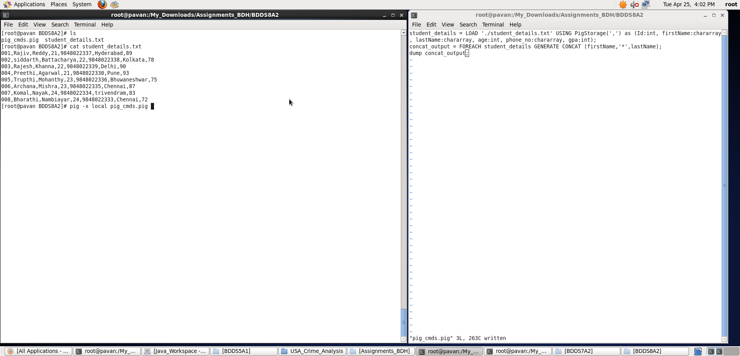

Output displayed: **<concat_output>**

**Note : We can store the output if required in a file using “store” command.**

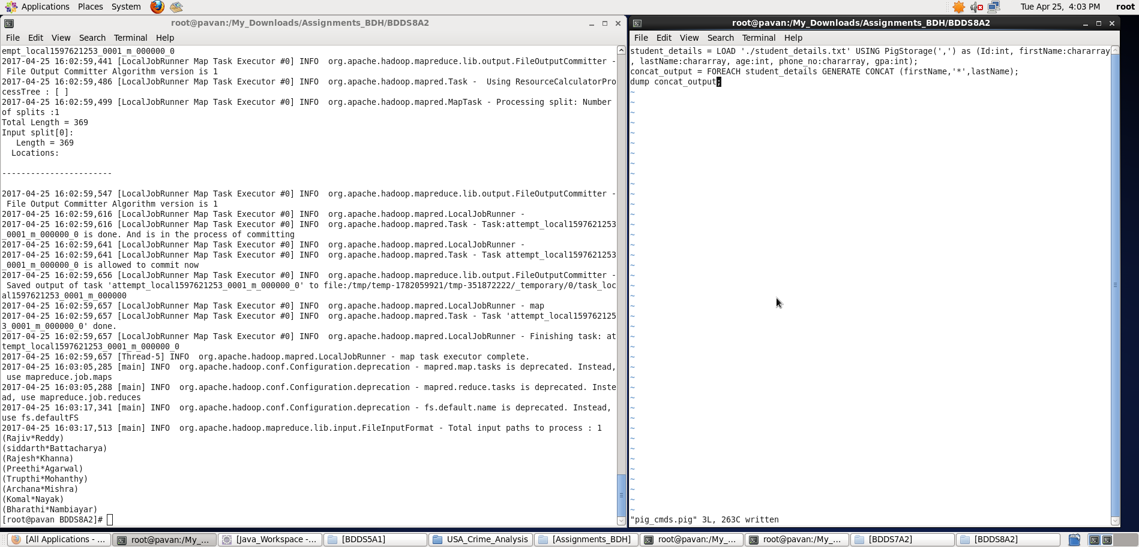

1. Tokenize

**Pig Latin Script**:

student_details = LOAD './student_details.txt' USING PigStorage(',') as (Id:int, firstName:chararray, lastName:chararray, age:int, phone_no:chararray, gpa:int);

concat_output = FOREACH student_details GENERATE CONCAT (firstName,'*',lastName);

dump concat_output;

**Explanation:**

* Loaded data from student_details.txt into “student_details” relation. Here ‘,’ is the delimiter and schema is provided accordingly
* Then, for all records I have generated a new relation which contains concatenated result of the firstName and lastName using CONCAT function. Here ‘*’ is kept in between the firstName and lastName and all the three expressions are concatenated.
* Outputting the concat_output

**Screenshots**

Running **Pig Latin Script in Local Mode** inside /My_Downloads/Assignments_BDH/BDDS8A2/ directory

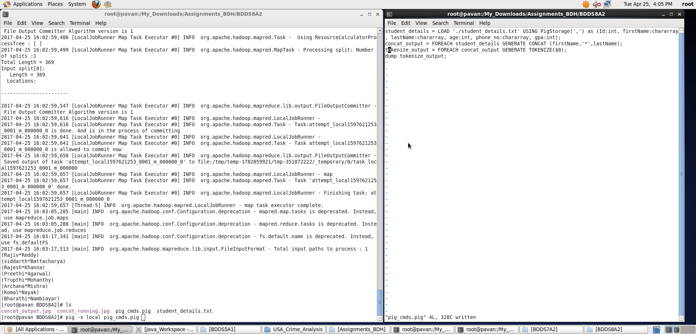

Output displayed: **<concat_output>**

**Note : We can store the output if required in a file using “store” command.**

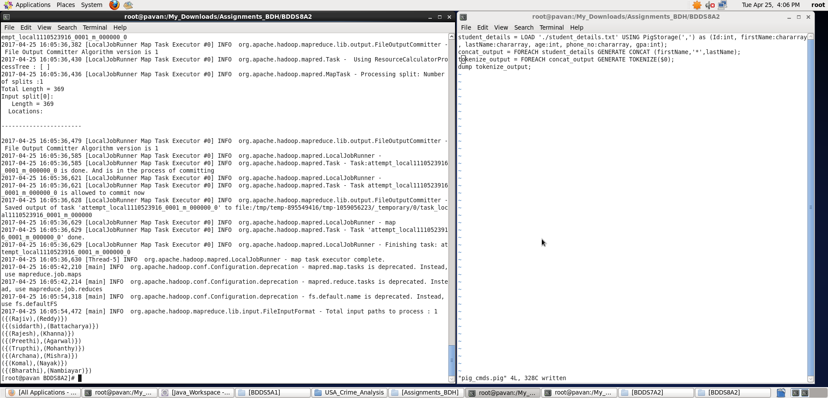

1. Sum

**Pig Latin Script**:

student_details = LOAD './student_details.txt' USING PigStorage(',') as (Id:int, firstName:chararray, lastName:chararray, age:int, phone_no:chararray, gpa:int);

concat_output = FOREACH student_details GENERATE CONCAT (firstName,'*',lastName);

dump concat_output;

**Explanation:**

* Loaded data from student_details.txt into “student_details” relation. Here ‘,’ is the delimiter and schema is provided accordingly
* Then, for all records I have generated a new relation which contains concatenated result of the firstName and lastName using CONCAT function. Here ‘*’ is kept in between the firstName and lastName and all the three expressions are concatenated.
* Outputting the concat_output

**Screenshots**

Running **Pig Latin Script in Local Mode** inside /My_Downloads/Assignments_BDH/BDDS8A2/ directory

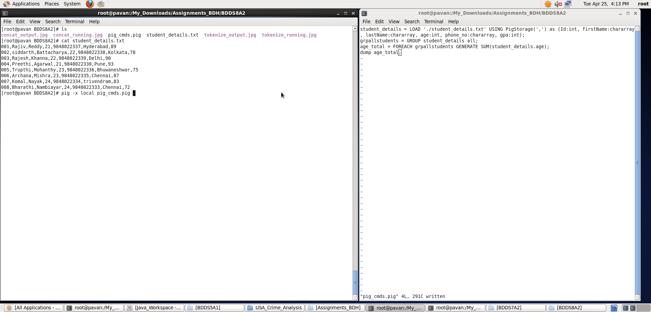

Output displayed: **<concat_output>**

**Note : We can store the output if required in a file using “store” command**

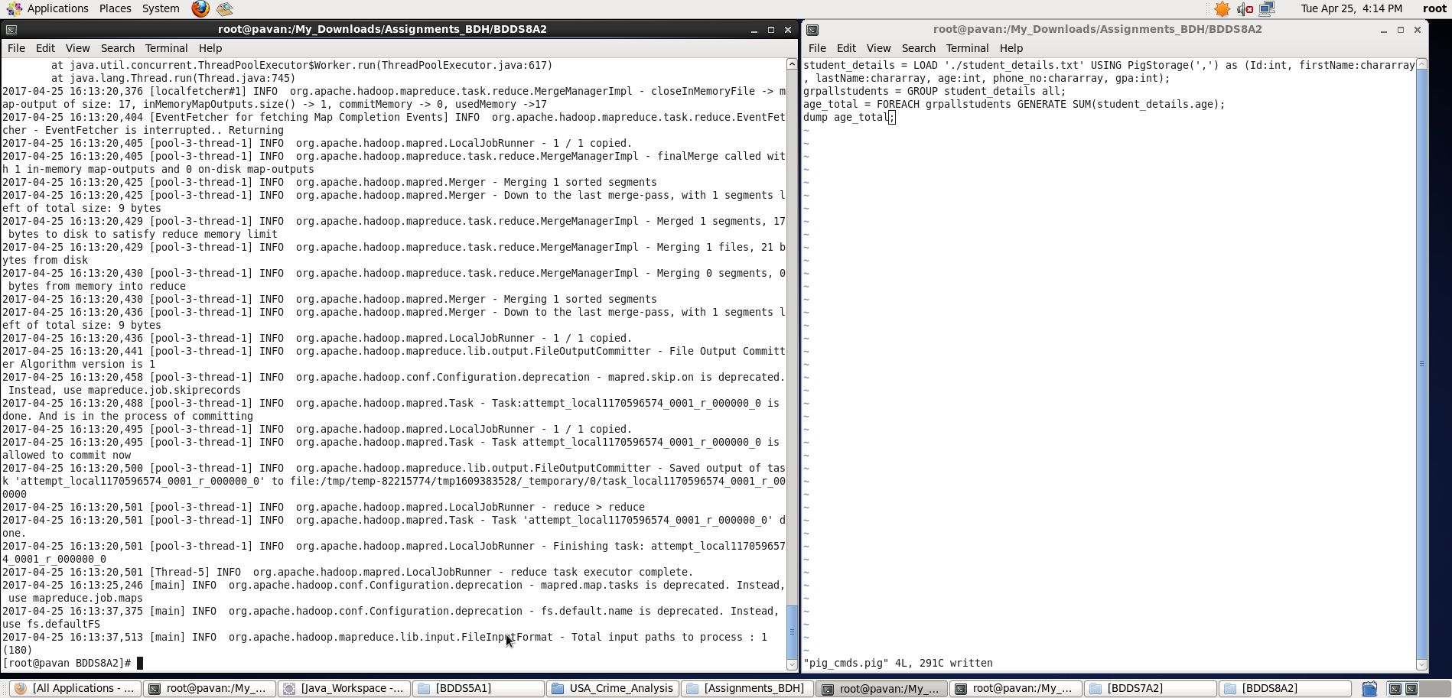

1. Min

**Pig Latin Script**:

student_details = LOAD './student_details.txt' USING PigStorage(',') as (Id:int, firstName:chararray, lastName:chararray, age:int, phone_no:chararray, gpa:int);

concat_output = FOREACH student_details GENERATE CONCAT (firstName,'*',lastName);

dump concat_output;

**Explanation:**

* Loaded data from student_details.txt into “student_details” relation. Here ‘,’ is the delimiter and schema is provided accordingly
* Then, for all records I have generated a new relation which contains concatenated result of the firstName and lastName using CONCAT function. Here ‘*’ is kept in between the firstName and lastName and all the three expressions are concatenated.
* Outputting the concat_output

**Screenshots**

Running **Pig Latin Script in Local Mode** inside /My_Downloads/Assignments_BDH/BDDS8A2/ directory

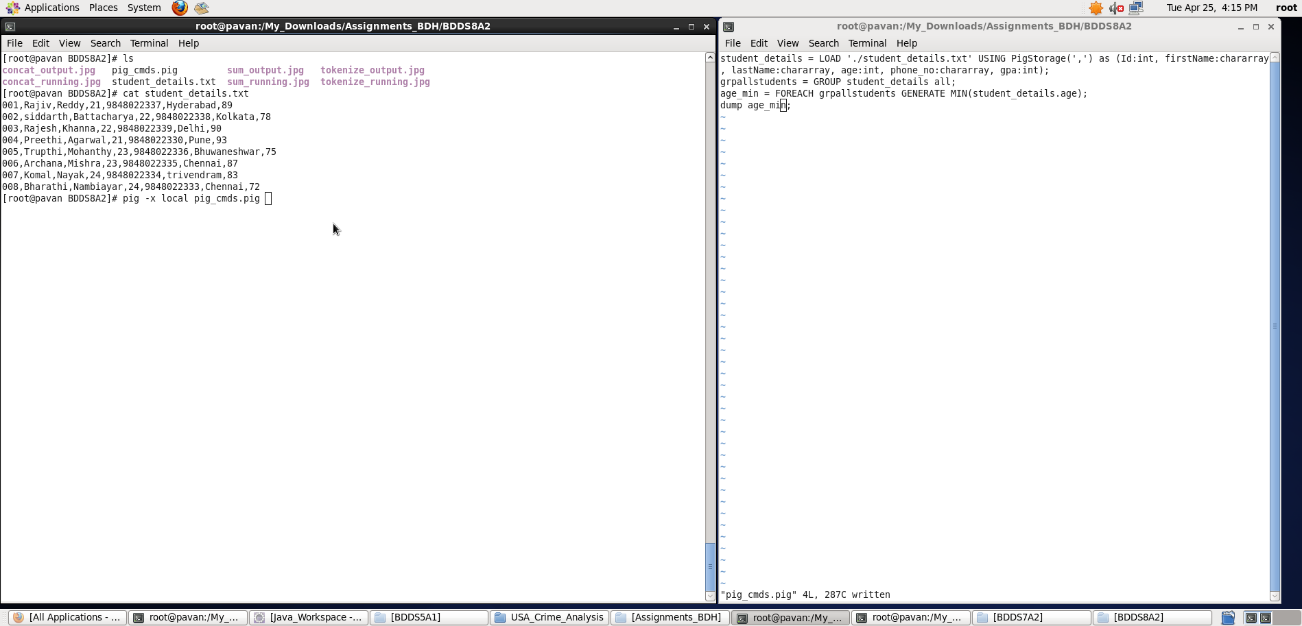

Output displayed: **<concat_output>**

**Note : We can store the output if required in a file using “store” command**

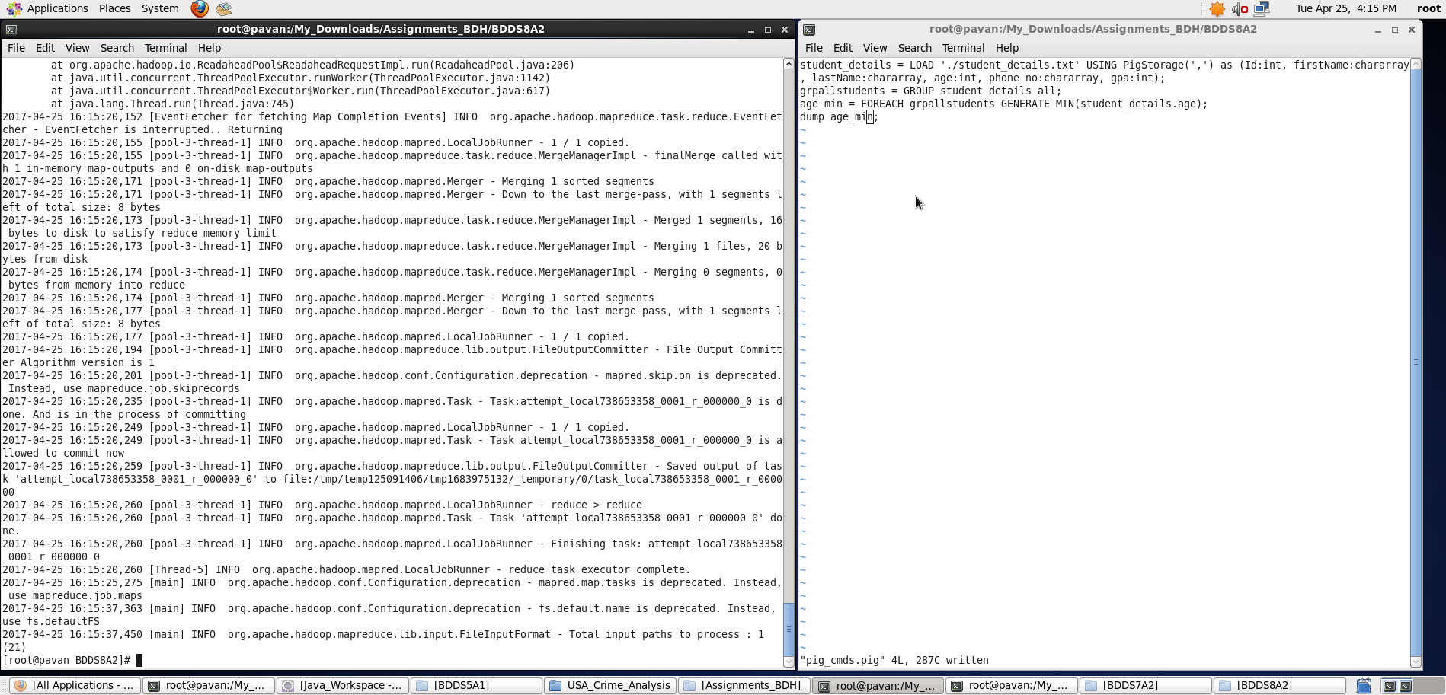

1. Max

**Pig Latin Script**:

student_details = LOAD './student_details.txt' USING PigStorage(',') as (Id:int, firstName:chararray, lastName:chararray, age:int, phone_no:chararray, gpa:int);

concat_output = FOREACH student_details GENERATE CONCAT (firstName,'*',lastName);

dump concat_output;

**Explanation:**

* Loaded data from student_details.txt into “student_details” relation. Here ‘,’ is the delimiter and schema is provided accordingly
* Then, for all records I have generated a new relation which contains concatenated result of the firstName and lastName using CONCAT function. Here ‘*’ is kept in between the firstName and lastName and all the three expressions are concatenated.
* Outputting the concat_output

**Screenshots**

Running **Pig Latin Script in Local Mode** inside /My_Downloads/Assignments_BDH/BDDS8A2/ directory

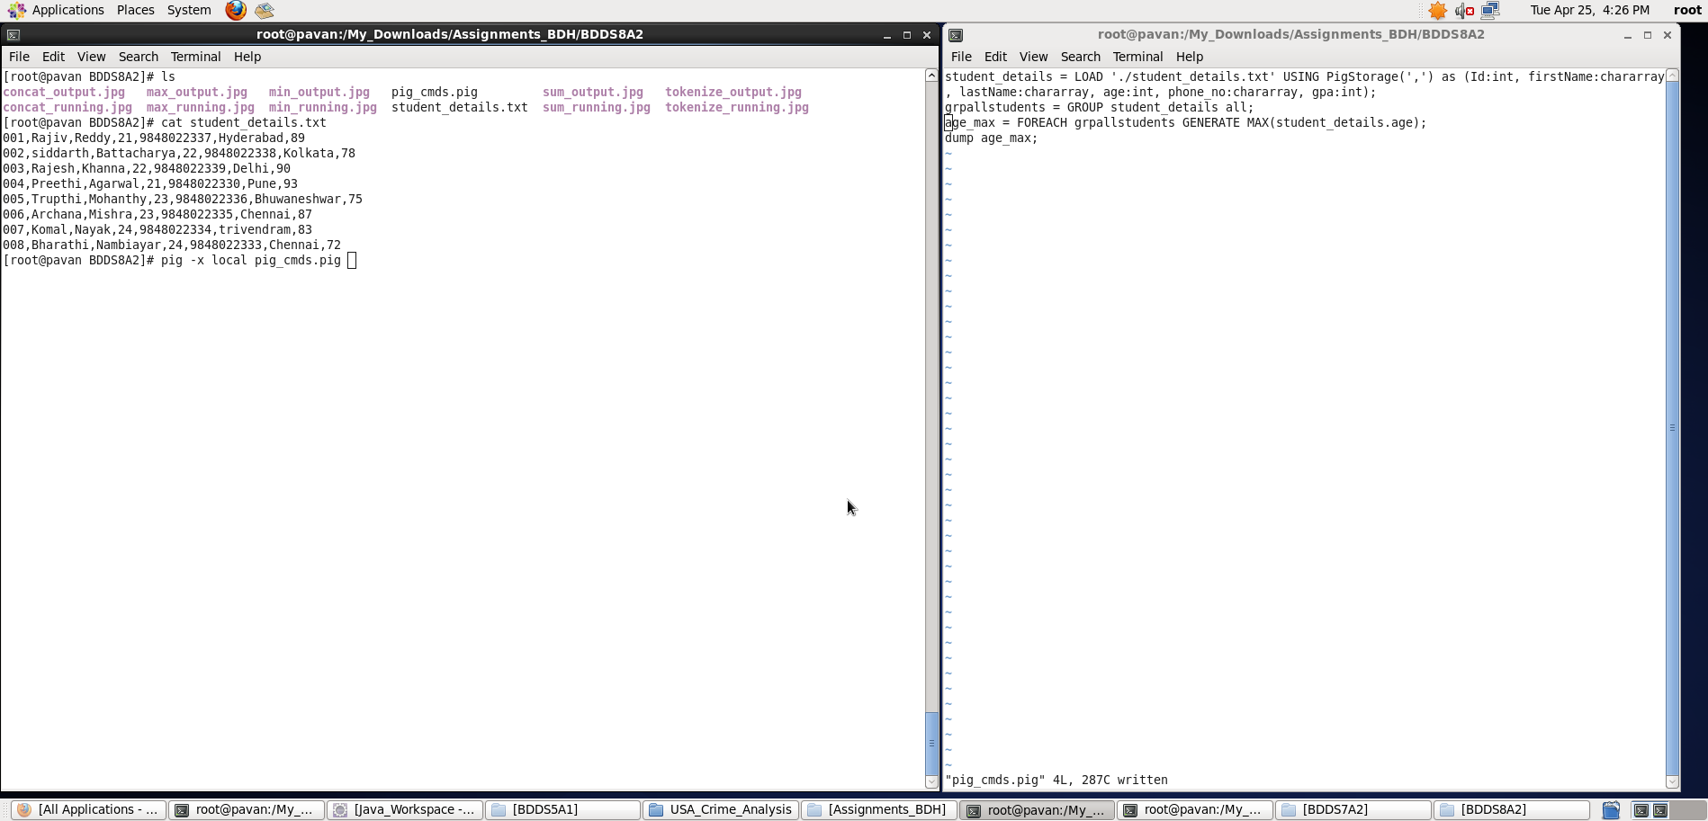

Output displayed: **<concat_output>**

**Note : We can store the output if required in a file using “store” command**

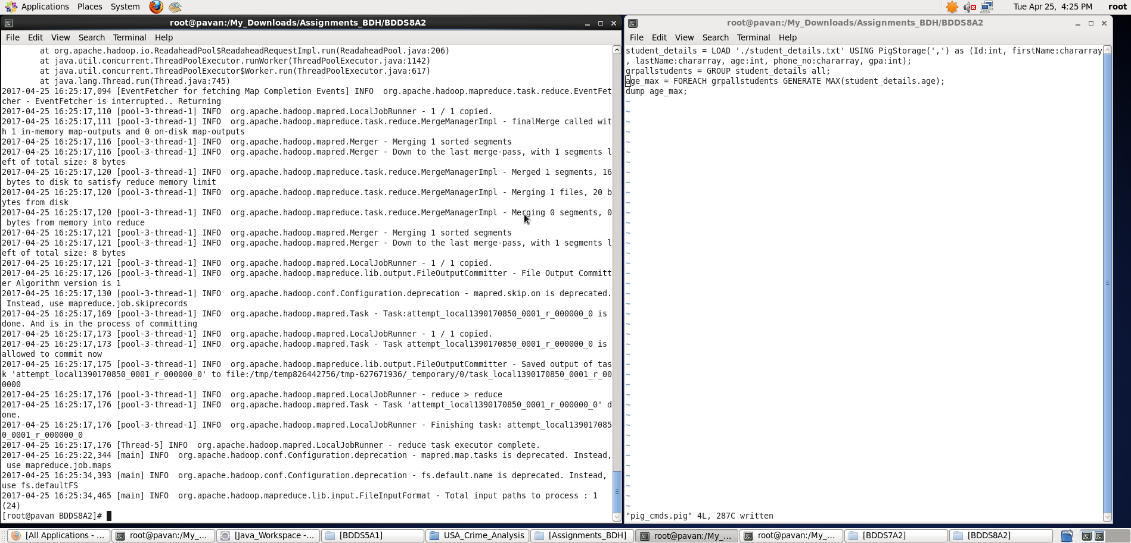

1. Limit

**Pig Latin Script**:

student_details = LOAD './student_details.txt' USING PigStorage(',') as (Id:int, firstName:chararray, lastName:chararray, age:int, phone_no:chararray, gpa:int);

concat_output = FOREACH student_details GENERATE CONCAT (firstName,'*',lastName);

dump concat_output;

**Explanation:**

* Loaded data from student_details.txt into “student_details” relation. Here ‘,’ is the delimiter and schema is provided accordingly
* Then, for all records I have generated a new relation which contains concatenated result of the firstName and lastName using CONCAT function. Here ‘*’ is kept in between the firstName and lastName and all the three expressions are concatenated.
* Outputting the concat_output

**Screenshots**

Running **Pig Latin Script in Local Mode** inside /My_Downloads/Assignments_BDH/BDDS8A2/ directory

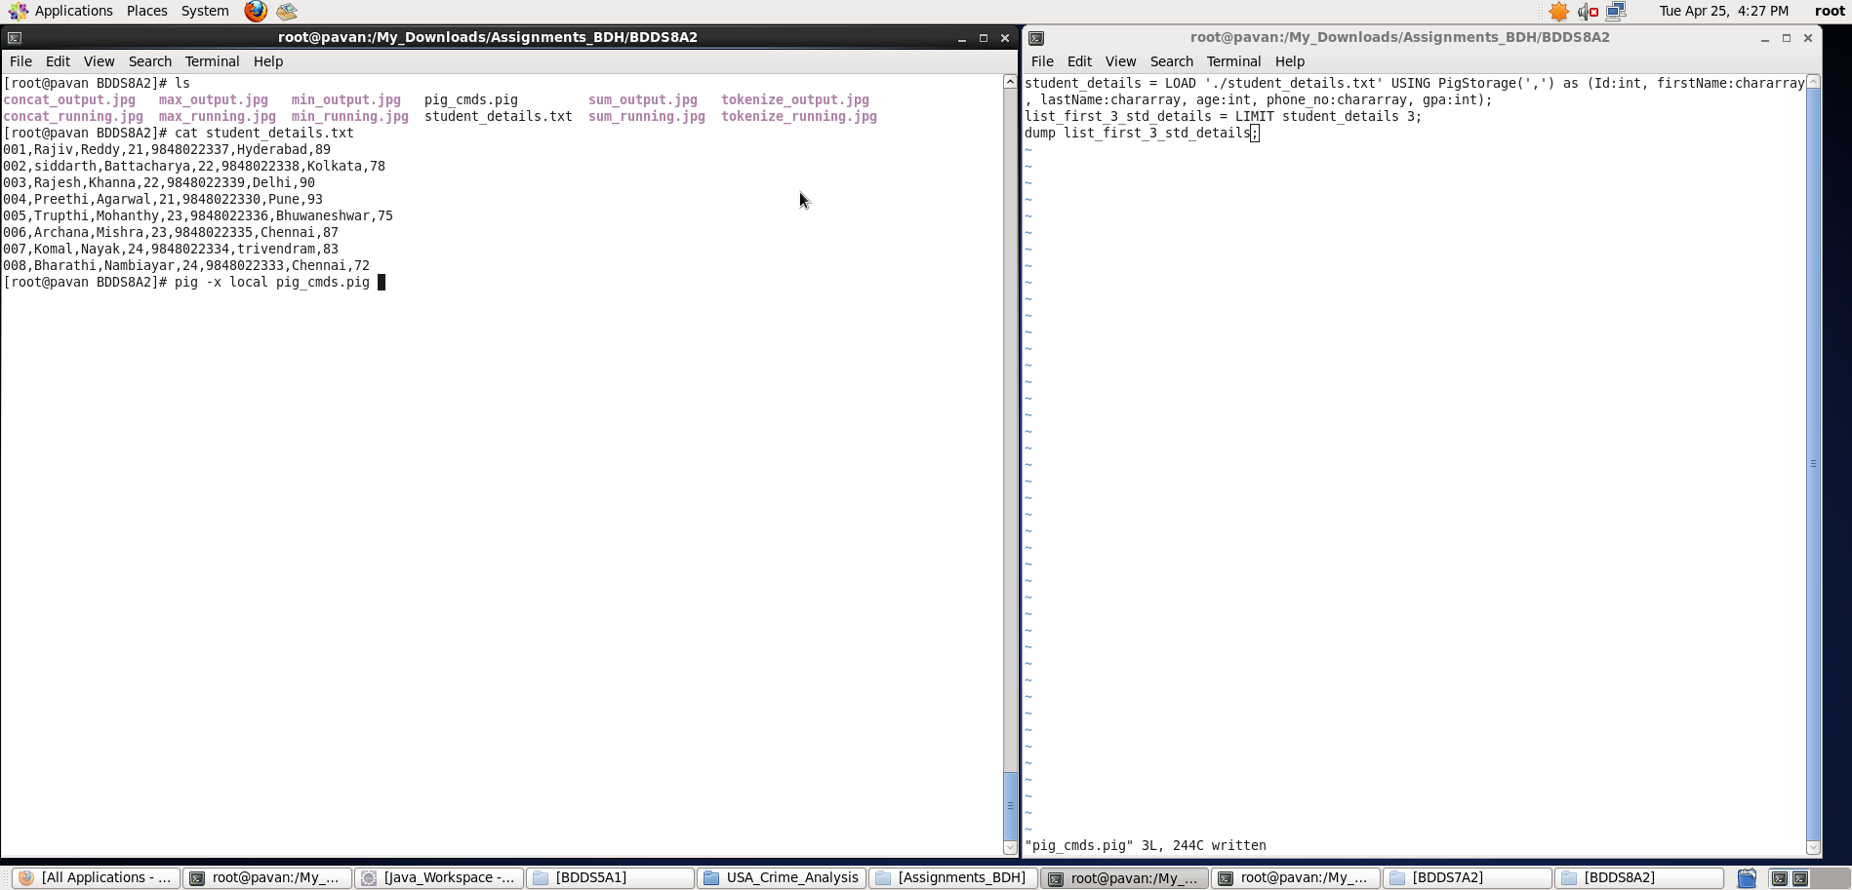

Output displayed: **<concat_output>**

**Note : We can store the output if required in a file using “store” command**

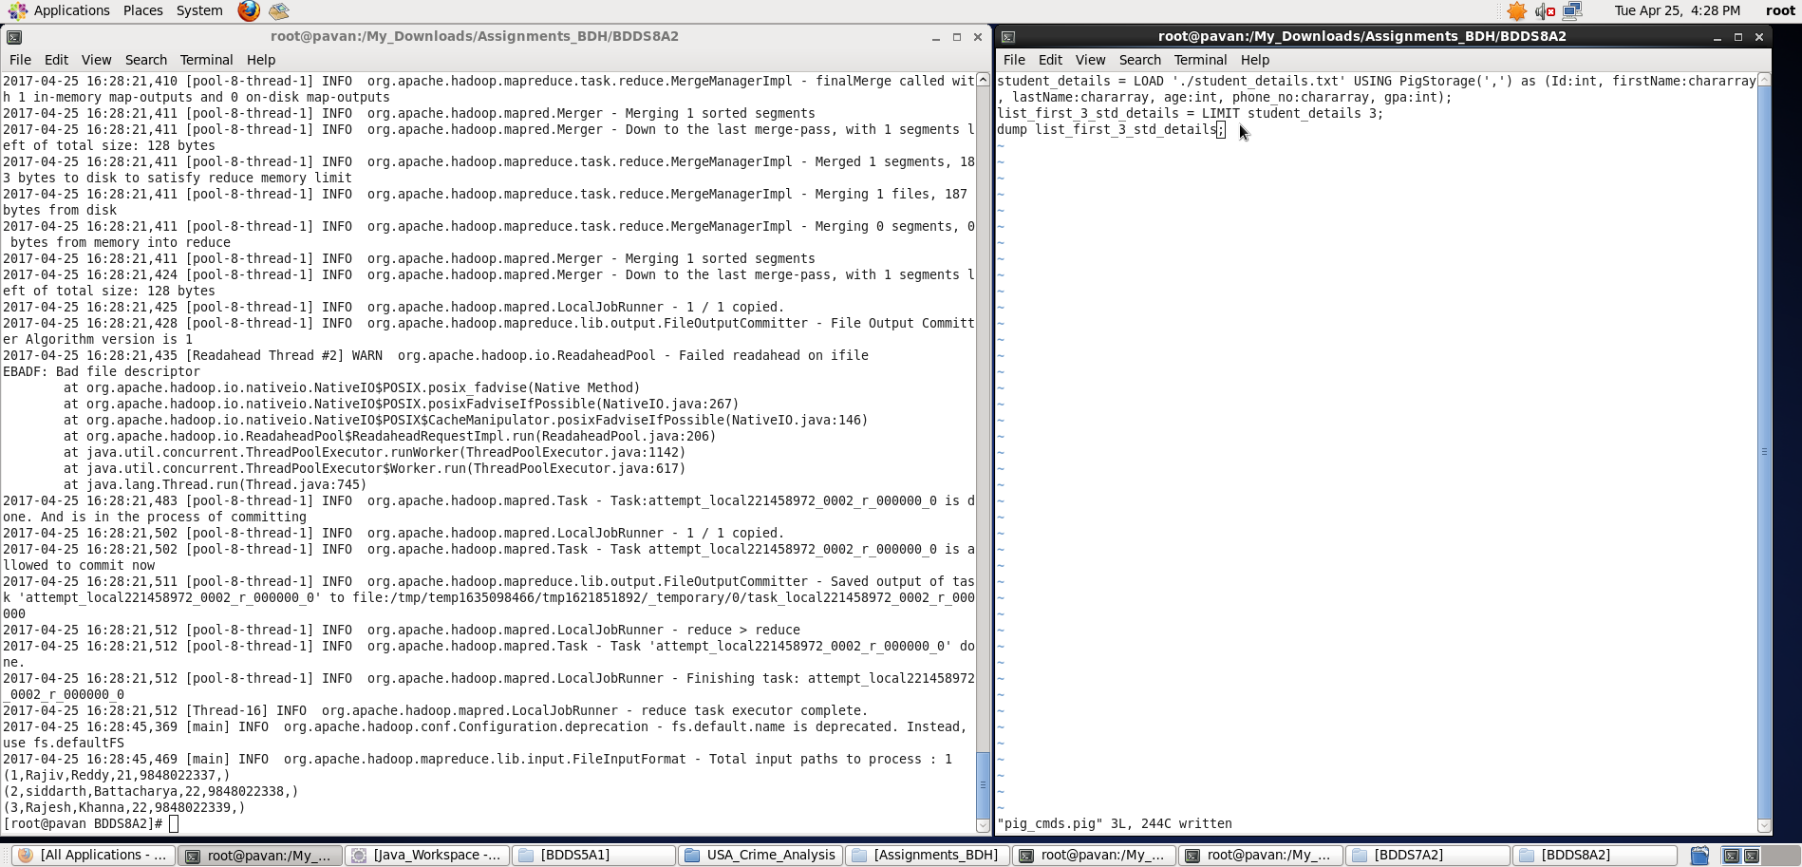

1. Store

**Pig Latin Script**:

student_details = LOAD './student_details.txt' USING PigStorage(',') as (Id:int, firstName:chararray, lastName:chararray, age:int, phone_no:chararray, gpa:int);

concat_output = FOREACH student_details GENERATE CONCAT (firstName,'*',lastName);

dump concat_output;

**Explanation:**

* Loaded data from student_details.txt into “student_details” relation. Here ‘,’ is the delimiter and schema is provided accordingly
* Then, for all records I have generated a new relation which contains concatenated result of the firstName and lastName using CONCAT function. Here ‘*’ is kept in between the firstName and lastName and all the three expressions are concatenated.
* Outputting the concat_output

**Screenshots**

Running **Pig Latin Script in Local Mode** inside /My_Downloads/Assignments_BDH/BDDS8A2/ directory

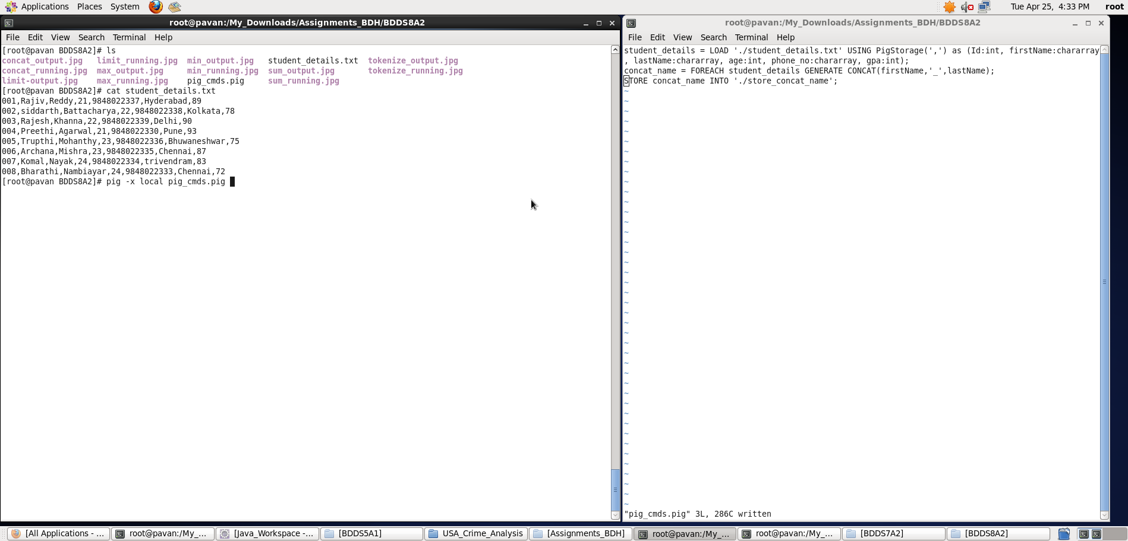

Output displayed: **<concat_output>**

**Note : We can store the output if required in a file using “store” command**

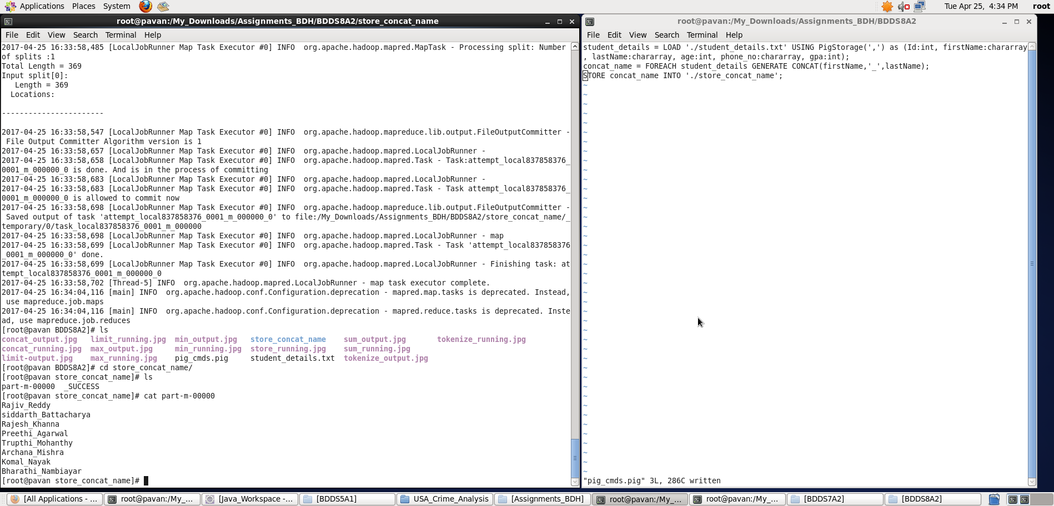

1. Distinct

**Pig Latin Script**:

student_details = LOAD './student_details.txt' USING PigStorage(',') as (Id:int, firstName:chararray, lastName:chararray, age:int, phone_no:chararray, gpa:int);

concat_output = FOREACH student_details GENERATE CONCAT (firstName,'*',lastName);

dump concat_output;

**Explanation:**

* Loaded data from student_details.txt into “student_details” relation. Here ‘,’ is the delimiter and schema is provided accordingly
* Then, for all records I have generated a new relation which contains concatenated result of the firstName and lastName using CONCAT function. Here ‘*’ is kept in between the firstName and lastName and all the three expressions are concatenated.
* Outputting the concat_output

**Screenshots**

Running **Pig Latin Script in Local Mode** inside /My_Downloads/Assignments_BDH/BDDS8A2/ directory

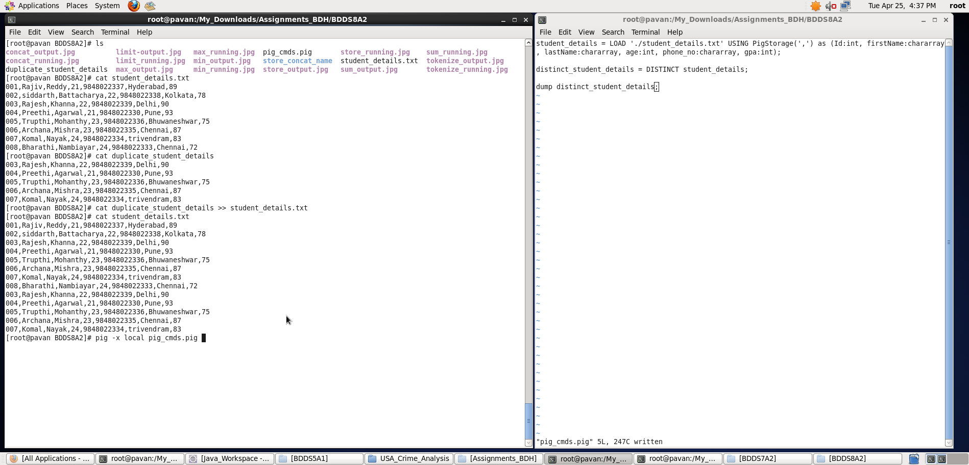

Output displayed: **<concat_output>**

**Note : We can store the output if required in a file using “store” command**

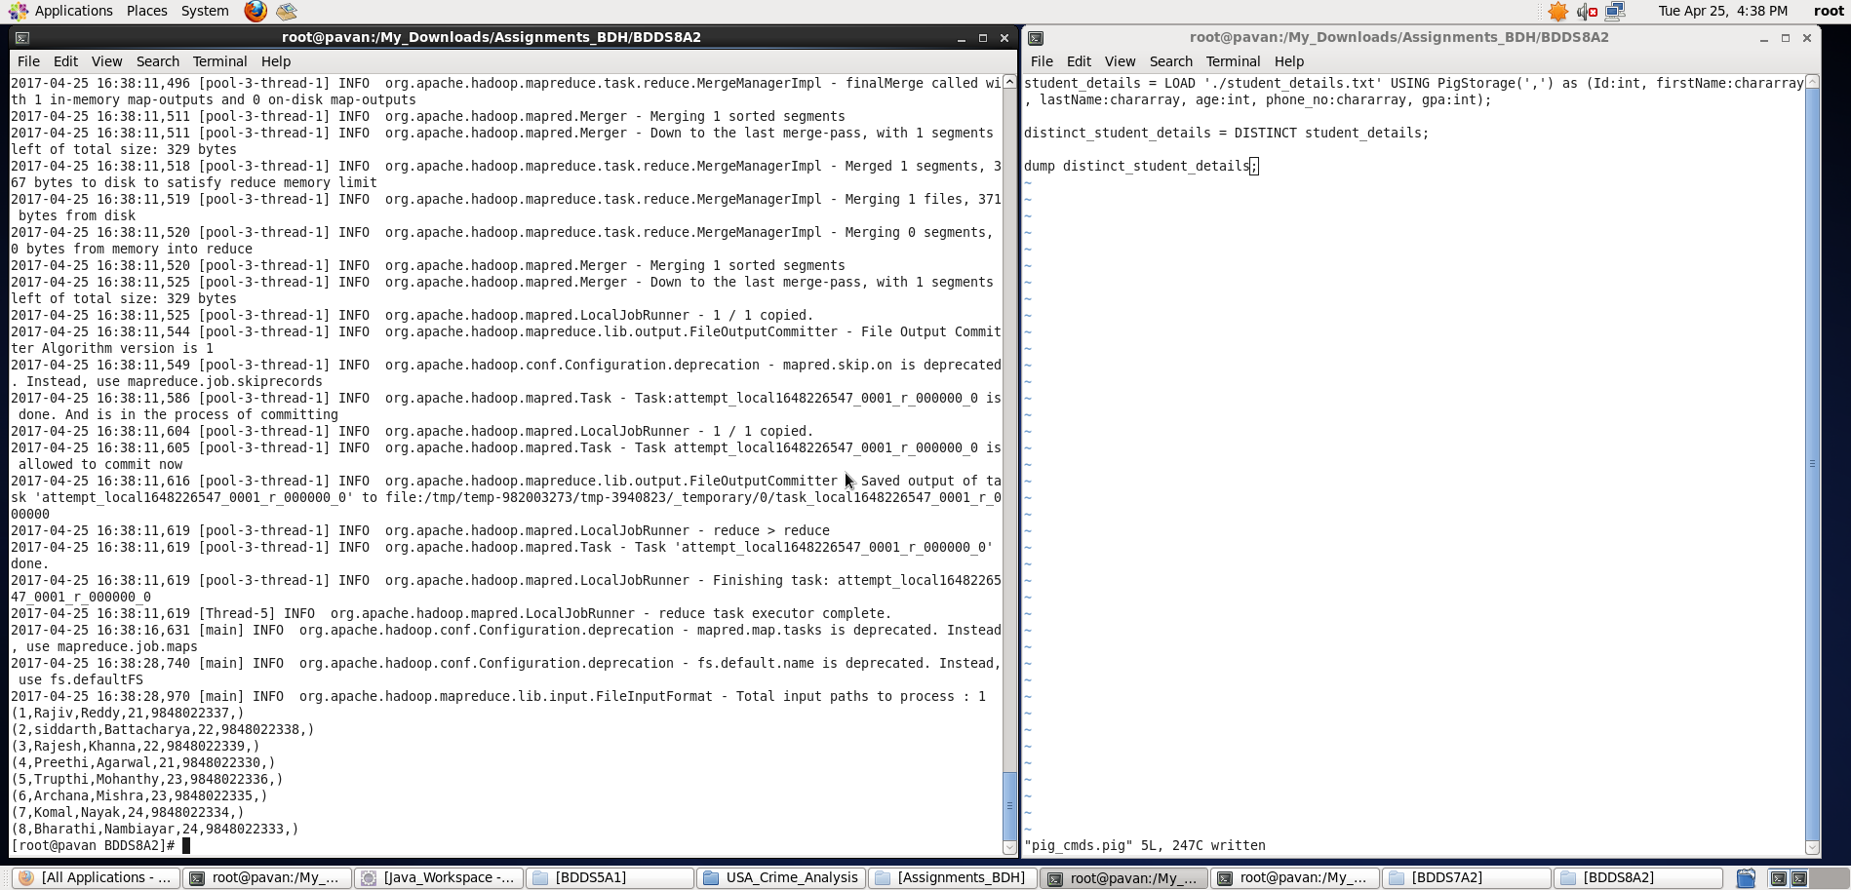

1. Flatten

**Pig Latin Script**:

student_details = LOAD './student_details.txt' USING PigStorage(',') as (Id:int, firstName:chararray, lastName:chararray, age:int, phone_no:chararray, gpa:int);

concat_output = FOREACH student_details GENERATE CONCAT (firstName,'*',lastName);

dump concat_output;

**Explanation:**

* Loaded data from student_details.txt into “student_details” relation. Here ‘,’ is the delimiter and schema is provided accordingly
* Then, for all records I have generated a new relation which contains concatenated result of the firstName and lastName using CONCAT function. Here ‘*’ is kept in between the firstName and lastName and all the three expressions are concatenated.
* Outputting the concat_output

**Screenshots**

Running **Pig Latin Script in Local Mode** inside /My_Downloads/Assignments_BDH/BDDS8A2/ directory

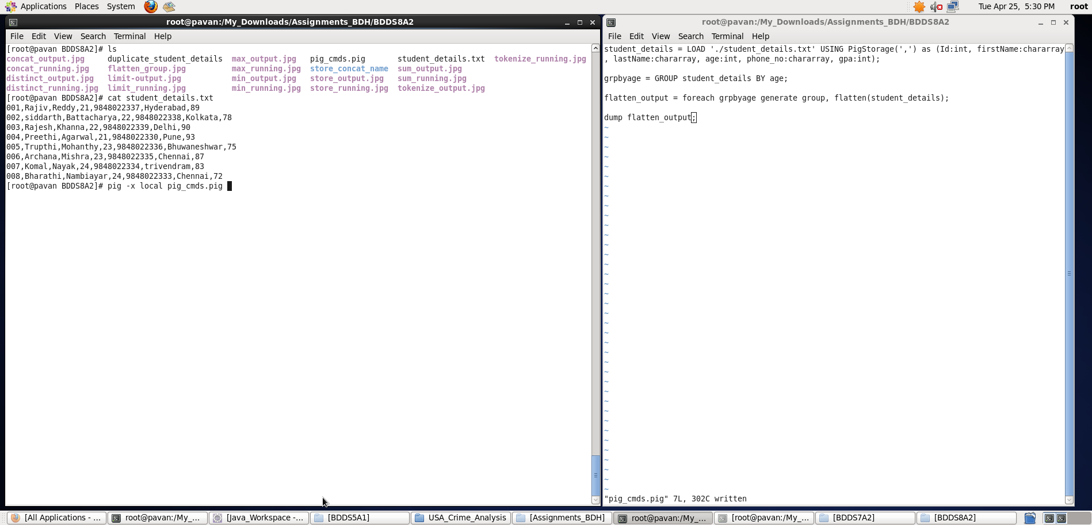

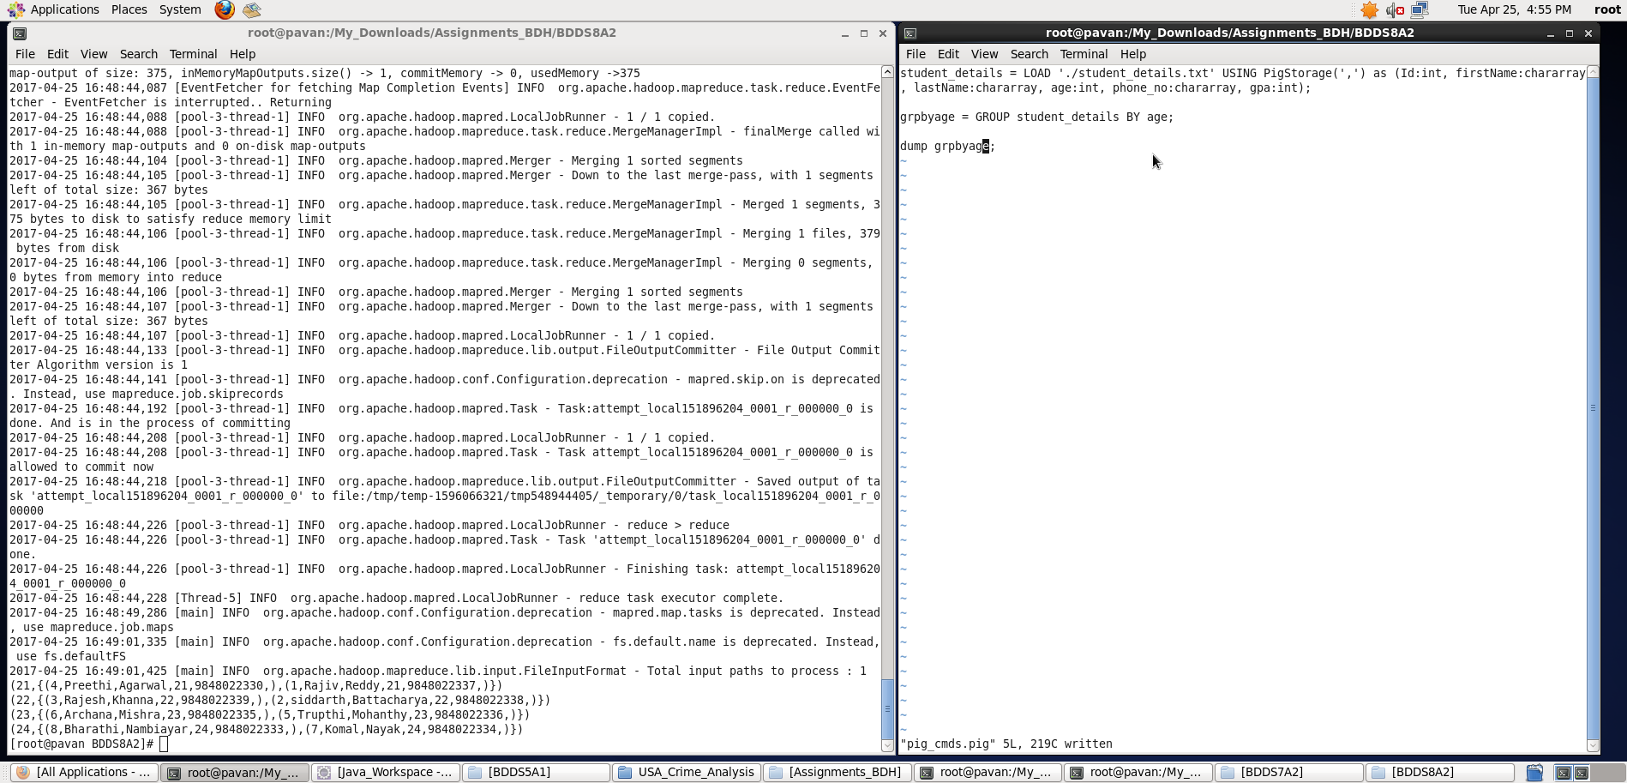

Output displayed: **<concat_output>**

**Note : We can store the output if required in a file using “store” command**

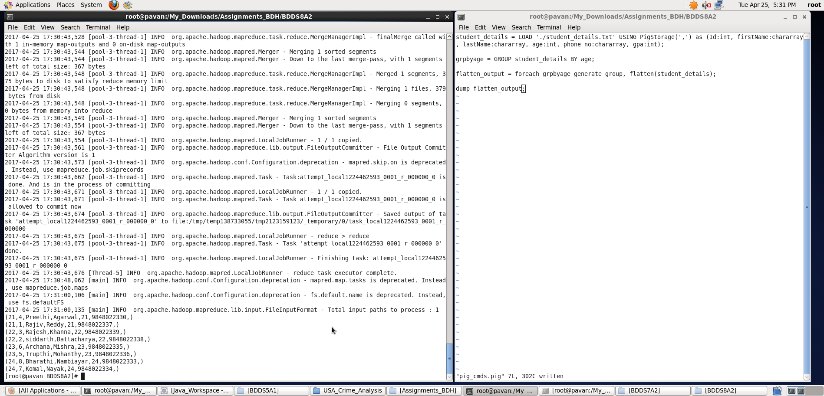

1. IsEmpty

**Pig Latin Script**:

student_details = LOAD './student_details.txt' USING PigStorage(',') as (Id:int, firstName:chararray, lastName:chararray, age:int, phone_no:chararray, gpa:int);

concat_output = FOREACH student_details GENERATE CONCAT (firstName,'*',lastName);

dump concat_output;

**Explanation:**

* Loaded data from student_details.txt into “student_details” relation. Here ‘,’ is the delimiter and schema is provided accordingly
* Then, for all records I have generated a new relation which contains concatenated result of the firstName and lastName using CONCAT function. Here ‘*’ is kept in between the firstName and lastName and all the three expressions are concatenated.
* Outputting the concat_output

**Screenshots**

Running **Pig Latin Script in Local Mode** inside /My_Downloads/Assignments_BDH/BDDS8A2/ directory

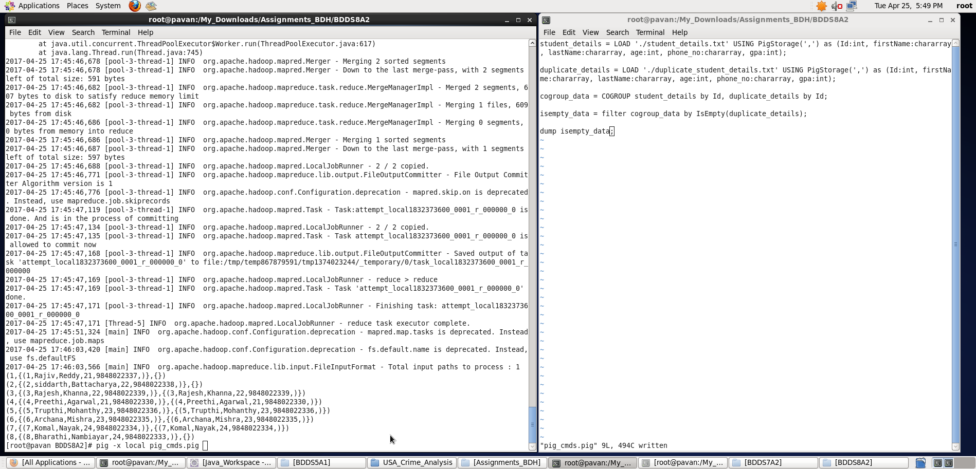

Output displayed: **<concat_output>**

**Note : We can store the output if required in a file using “store” command**

